PRESS RELEASE FOR IMMEDIATE RELEASE

CRISTOS GIANAKOS

January 15 – February 19, 2005
Opening Reception: January 15, 2005 from 6-8 pm

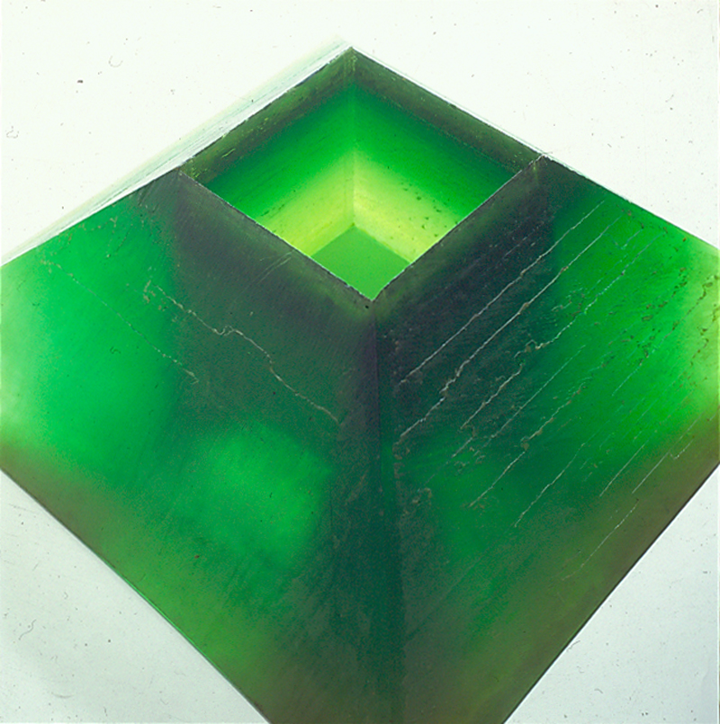

In his current exhibition, Gianakos has chosen to include an important and rarely seen series of sculptures from 1968-1972. Created during the high period of Minimalism and Process art, these polyester resin works reflect the concerns of the major sculptors working at that time.

Some of the works employ the natural color of the material, and others show a hint of green pigment, giving them an ethereal translucent quality of beauty. The process of daily pouring can be seen in the layered horizontal formations, much as the earth’s depths betray different geological time periods and life histories.

Gianakos’ long-standing interest in architecture and ancient cultures, reflected in his explorations of geometric forms and classic proportions, have been of paramount importance to him for decades. These concerns can also be seen in his subsequent series of large-scale sculptures, from the 1970’s and 1980’s, which he titled “Rampworks.” Many of these have been seen throughout this country as well as in various venues in Europe. Finally, the exhibition includes a recent steel cube sculpture as well as new works from his “Metropolis” series of paintings on mylar and steel wall reliefs.

Cris Gianakos was born in New York and spent his first five years in Greece. He attended the School of Visual Arts, where he also has taught for the past 35 years. He has had numerous solo exhibitions in the U.S.A., Europe and Japan. Gianakos is represented in many public and private collections, including the Museum of Modern Art and other major institutions here and abroad. Gianakos has been the recipient of a variiety of grants and awards; these include the NEA, the Pollock-Krasner Foundation, NYFA and others. Last summer he completed a large installation for the city of Athens, Greece for the 2004 Olympics.

